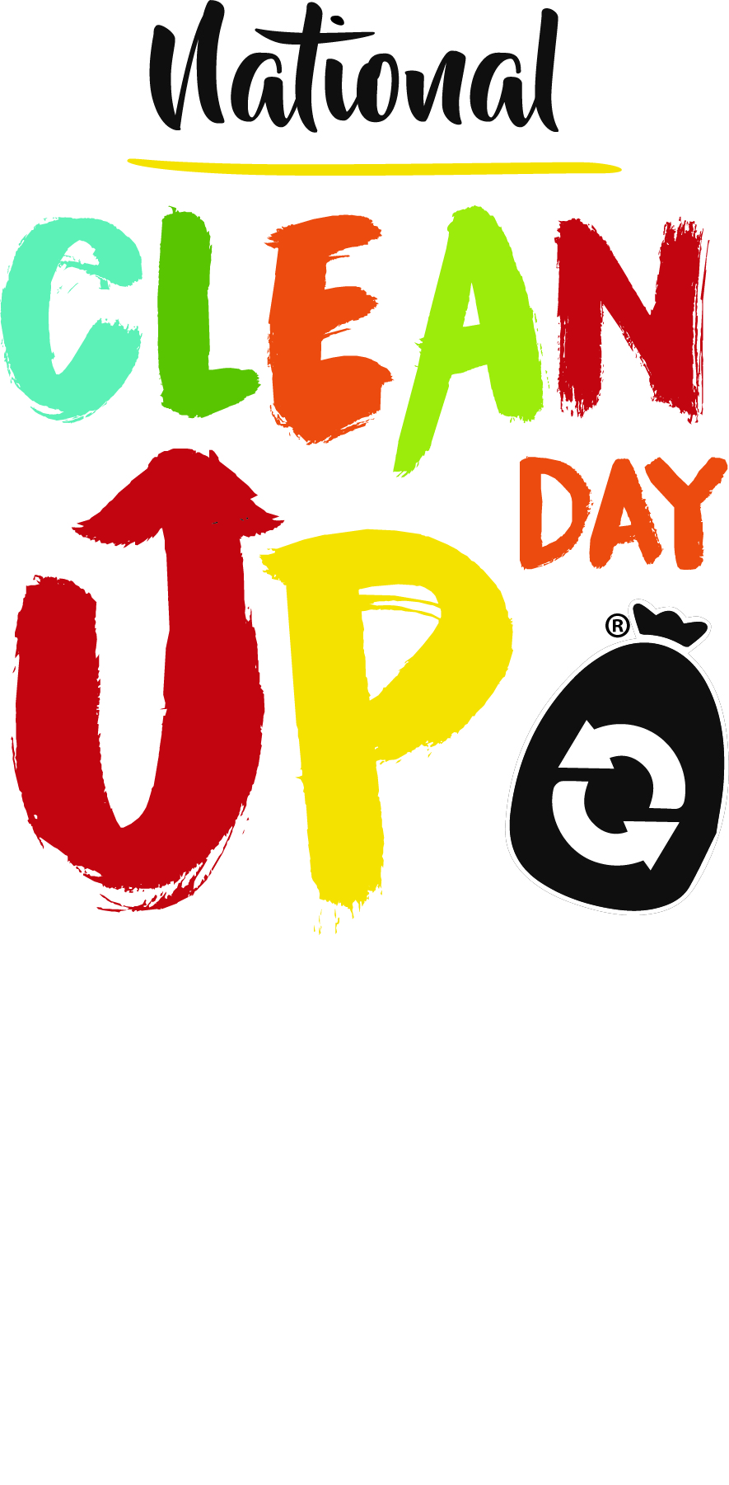

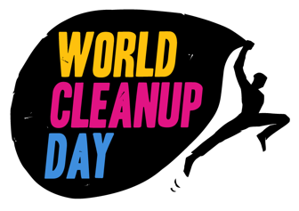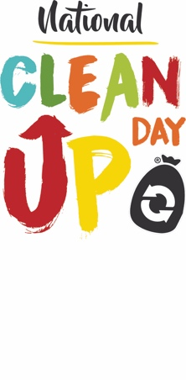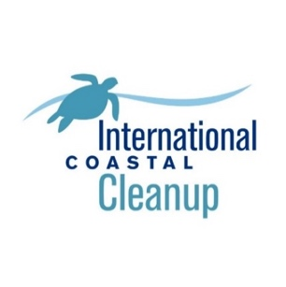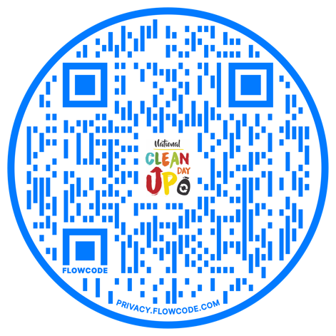

**From Sea to Shining Sea**

**Saturday, September 16, 2023**

**Register** at NationalCleanUpDay.org or by pointing your camera at the QR code!

**Take action against litter!** Form a team or go out on your own. Any street or natural area of your choice.

**National CleanUp Month** is all of September.

NationalCleanUpDay.org